Data analysis project

The Analysis of CO₂ Emissions and Fuel Consumption of Gas-Powered Vehicles
Yassin Sameh (23-101192)
Saif Alaa Eldin Fathy (23-101113)
Yousuf Idrees (23-101077)
Omar Sayed (23-101091)

Introduction:
Gasoline-powered vehicles are one of the largest contributors to greenhouse gases that are accelerating climate change and affecting public health. With sustainability being a priority in the world today, understanding which vehicle characteristics have the greatest influence on CO₂ emissions is important. This report reviewed several characteristics—engine size, fuel type, transmission, and vehicle class—and what impact these attributes have on fuel consumption and pollution, with gas-powered vehicles accounting for a significant share. This project explores the relationships between various vehicle characteristics such as engine size, fuel type, transmission system, and vehicle class and their impact on fuel efficiency and CO₂ emissions. Using a dataset containing specifications for 1000 gas-powered vehicles, we perform exploratory data analysis to identify key trends and correlations. The goal is to uncover how these features influence pollution levels and to provide insights that can guide efforts in promoting cleaner, more efficient transportation options.

Research question:
Do vehicle characteristics and fuel type significantly affect CO₂ emissions in gas-powered cars?

Hypothesis:
We tested the following hypotheses:
- H₀: There is no significant difference in CO₂ emissions between vehicle classes.
- H₀: The number of engine cylinders is not significantly associated with CO₂ emissions.
- H₀: Fuel type does not significantly affect CO₂ emissions.
- H₀: There is no correlation between fuel consumption and CO₂ emissions.
In each case, we tested against the alternative that there is a significant relationship.
CO₂ emissions are associated with the number of engine cylinders. If fuel type significantly affects CO₂ emissions. There is a correlation between fuel consumption and CO₂ emissions
We failed to reject the Null hypothesis. There is no relation or weak relation between the vehicle’s characteristics and CO₂ emissions in gas powered vehicles. City vs Highway Fuel Consumption a highly significant difference was detected: vehicles consume more fuel in city.

Population of Interest:
All gas-powered passenger vehicles currently available in the market, as represented in the dataset, which includes various brands and models.
Sampling Method:
We used simple random sampling to choose 1,000 vehicle records from a more extensive registry. This approach reduces any potential bias in the sample and guarantees a diverse representation of various vehicle types and manufacturers.
Bias Identification:
To minimize bias, we ensured the dataset includes various vehicle classes, engine types, and manufacturers. Electric and hybrid vehicles were intentionally excluded to focus on gas-powered cars. However, potential bias may arise if certain brands or models are overrepresented in the dataset.
Collected Data / Dataset:
Vehicle Class | Category of the vehicle (e.g., SUV, Compact)
Engine Size (L) | Displacement volume of the engine
Cylinders | Number of engine cylinders
Fuel Type | Type of fuel used
Fuel Consumption (L/100km) | Fuel used per 100 Km
CO₂ Emissions (g/km) | Amount of CO₂ emitted per Km

Analysis:
First, we constructed a scatter plot that visualizes the relation between the engine size and the CO₂ emissions. The x axis shows the engine size and y axis shows the CO₂ emissions.

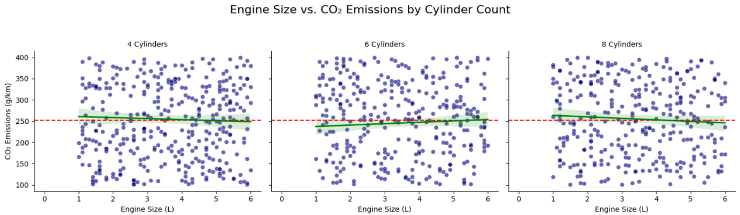

Then, we constructed a bar chart that visualizes the percentage between the fuel type and the vehicle classes.
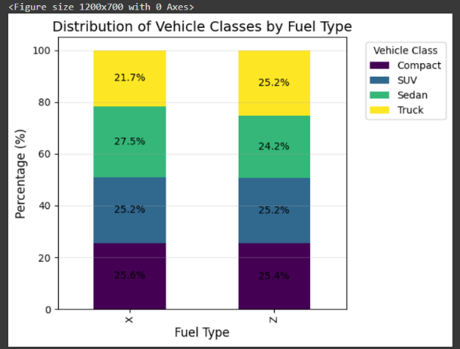

Then, we constructed a bar chart that shows the CO₂ emissions and vehicle type and the fuel type.
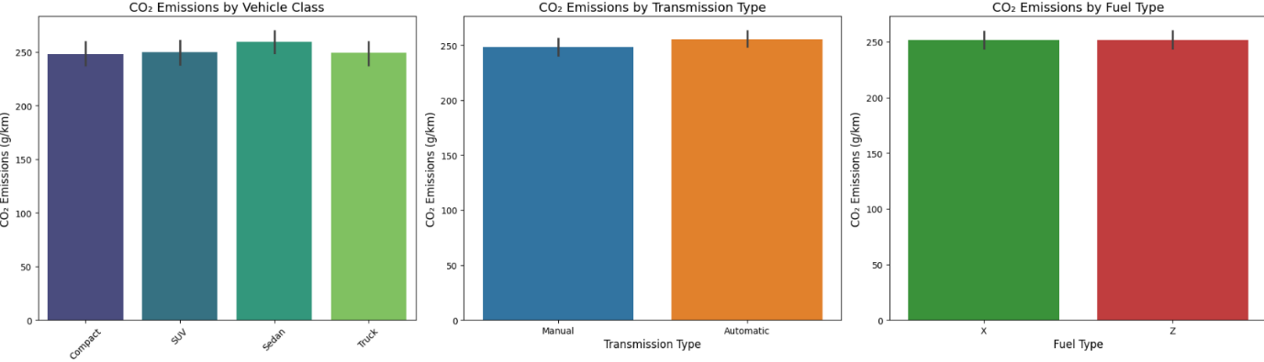

Hypothesis Testing Steps:
We used different tests among our analysis such as Anova and z test and chai squared.
Step 1: Formulate the null and alternative hypotheses for each relationship.
Step 2: Choose a significance level (α = 0.05).
Step 3: Apply the appropriate statistical test (e.g., ANOVA for vehicle class, chi-squared test for categorical comparisons, Z-test for means).
Step 4: Compare the p-value with α. If p < α, reject the null hypothesis.

Conclusion:
This study analysed the influence of engine characteristics, vehicle class, and fuel type on CO₂ emissions. While no statistically significant differences were found between vehicle classes or cylinder numbers, city driving showed significantly higher fuel consumption than highway driving. This suggests usage context has a greater impact than hardware specifications.
Limitations: The dataset excludes electric/hybrid vehicles and may not reflect market trends.
Implications: Policymakers and manufacturers can use these findings to focus efforts on improving city-driving efficiency.

Potential Issues
Some potential issues with this analysis include overrepresentation of certain manufacturers, lack of newer model year vehicles, and exclusion of non-gas-powered vehicles. These limitations could affect the generalizability of results.

